The Agile methodology is **a project management approach that involves breaking the project into phases and emphasizes continuous collaboration and improvement**. Teams follow a cycle of planning, executing, and evaluating.

Key: serial to parallel work

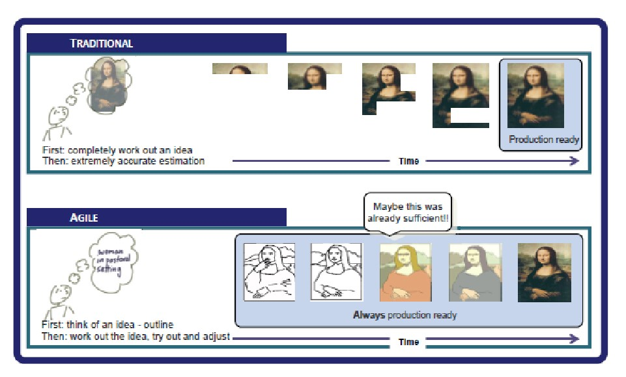

Based on their combined experience of developing software and helping others do that, the authors of the manifesto declared that they valued:

4 Pillars of Agile

Individuals and interactions over processes and tools  
Working software over comprehensive documentation  
Customer collaboration over contract negotiation  
Responding to change over following a plan

12 Principles of Agile

1) Our highest priority is to satisfy the customer through early and continuous delivery of valuable software.  
  
2) Welcome changing requirements, even late in development. Agile processes harness change for the customer’s competitive advantage.  
  
3) Deliver working software frequently, from a couple of weeks to a couple of months, with a preference to the shorter timescale.  
  
4) Business people and developers must work together daily throughout the project.  
  
5) Build projects around motivated individuals. Give them the environment and support they need, and trust them to get the job done.  
  
6) The most efficient and effective method of conveying information to and within a development team is face-to-face conversation.  
  
7) Working software is the primary measure of progress.  
  
8) Agile processes promote sustainable development. The sponsors, developers, and users should be able to maintain a constant pace indefinitely.  
  
9) Continuous attention to technical excellence and good design enhances agility.  
  
10) Simplicity–the art of maximizing the amount of work not done–is essential.  
  
11) The best architectures, requirements, and designs emerge from self-organizing teams.  
  
12) At regular intervals, the team reflects on how to become more effective, then tunes and adjusts its behaviour accordingly.

Casestudy:

1. Time saving by Agile and microservice.
2. FDD, TDD and BDD design model